NEXT JS Basics

Important links

1. <https://nextjs.org>
2. <https://react.dev>

**Installation**

Step 1

Node.js is require for the development of the next js project <https://nodejs.org/en>

Step 2

To Setup and install Next.js

write npx create-next-app@latest or npx create-next-app@version for example

npx create-next-app@13.4.7

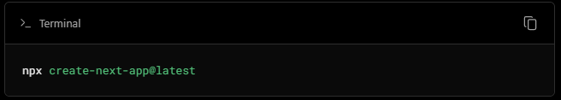

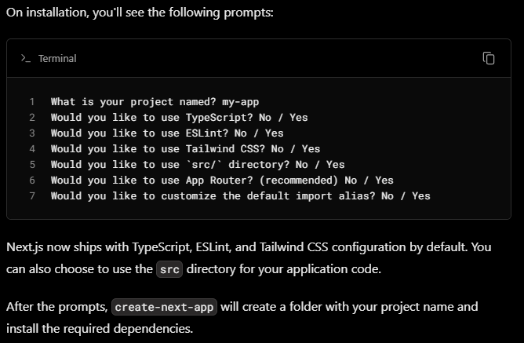

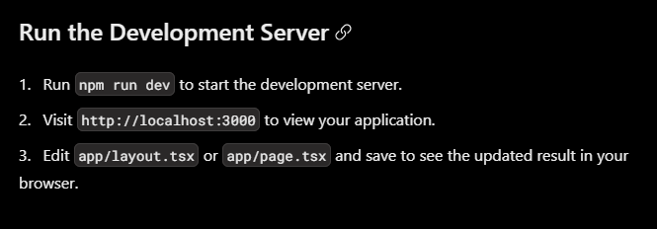

Github Download project installing dependances

Command:

npm I or npm install